[Android Mobile Automation Testing with Selenium WebDriver](http://selenium-suresh.blogspot.com/2013/01/android-mobile-automation-testing-with.html)

1. **Setup the Emulator**

**Introducing Android WebDriver**  
Selenium WebDriver is a browser automation tool which provides a lightweight and elegant way for testing web apps. Selenium WebDriver is now available as an SDK extra in the Android SDK, and supports 2.3 (Gingerbread) and onwards!  
Whether or not your site is optimized for mobile browsers, you can be sure that users will be accessing it from their phones and tablets. WebDriver makes it easy to write automated tests that ensure your site works correctly when viewed from the Android browser. We’ll walk you through some basics about WebDriver and look at it in action.  
**WebDriver(Android Driver) Baciscs**  
WebDriver tests are end-to-end tests that exercise the web application just like a real user would. WebDriver models user interactions with a web page such as finger flicks, finger scrolls and long presses. It can rotate the display and interact with HTML5 features such as local storage, session storage and the application cache. Those tests run as part of an Android tests project and are based on Junit. They can be launched from Eclipse or the command line. WebDriver tests can be wired with a continuous integration system and can run on phone and tablet emulators or real devices. Once the test starts, WebDriver opens a WebView configured like the Android browser and runs the tests against it.   
  
**Installation of Android SDK**  
1. Download installer from <http://developer.android.com/sdk/index.html>   
2. Install it to a location (like: C:\Program Files\Android)   
3. Launch “SDK Manager.exe”   
4. It will launch “Android SDK and AVD Manager”. By default “Installed packages” will be highlighted. On the pop up “Choose Packages to install”, there will be some packages selected already. Go ahead with the “Install”.

[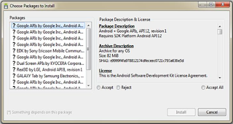](http://4.bp.blogspot.com/-oucdfIzwlnw/UPPrgLW9ETI/AAAAAAAAAE8/gS6e-krw5Nk/s1600/AVD+Manager.png)

5. Once it is done, select “Virtual Devices” to create one for you. Click on “New” and enter some name. Target as “Android 2.2 – API Level 8” (or) select from dropdown. Select Size as “512” and “Built-in” to be “WVGA854” and click on “Create AVD”.

[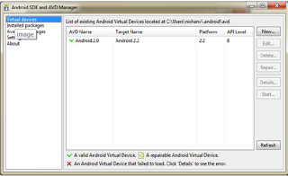](http://2.bp.blogspot.com/-yi1YUT8iqUM/UPPrxtMbzII/AAAAAAAAAFE/quUV0BlEi4E/s1600/AVD+Manager+start.png)

6. Once done select the Virtual device you created and click on Start. You can find the “Start” button on the right panel in the above shown image. Clicking “Start” will launch another pop-up, just say “Launch” and proceed.  
7.Once its opened you can see the image as below

[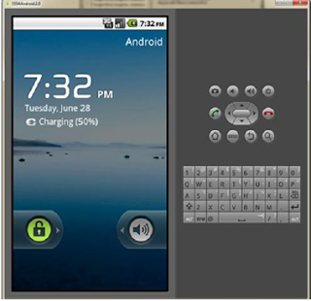](http://4.bp.blogspot.com/-BD8frcSBY3Y/UPPr-FhG-DI/AAAAAAAAAFM/Zbjmgq66iOk/s1600/Android+Virtual+Mobile.png)

**Install webdriver APK in Android Device**   
1. Download “android-server-2.0.2rc3.apk ” from the following location http://code.google.com/p/selenium/downloads/list  
2. Copy the above downloaded file into folder “C:\Program Files\Android\android-sdk\platform-tools”  
3. Run the “Command Prompt” as administrator.  
4. Execute “cd C:\Program Files\Android\android-sdk\platform-tools”  
5. Execute the command “adb install android-server-2.0.2rc3.apk”  
6. We also need to set up Port forwarding, run the command “adb forward tcp:8080 tcp:8080"  
7. Click on the WebDriver app on Emulator and this will make the android server available at “http://localhost:8080/wd/hub”. Opening this URL in Firefox will show up a blank page on success.  
8. Confirm the following settings on your emulator: Settings -> Applications -> Development -> Check "USB debugging", "Stay Awake" and "Allow mock locations".  
9. Launch the emulator, it will have Webdriver installed. When you launch the Webdriver, it will confirm “jetty started”  
10.WebDriver installed successfully as shown in below image.

[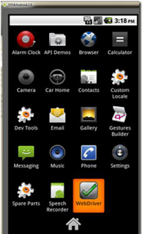](http://2.bp.blogspot.com/-pJzisybpOpM/UPPsKiLLx4I/AAAAAAAAAFU/zKgbsJuFf3o/s1600/WebDriver+in+Android+virtual+device.png)

1. Configure the Eclipse (Indigo or Hellios)